1

Exercise 2.2 – Hello JavaScript

Eric McCool
Bellevue University School of Science and Technology
Web231-339A Enterprise JavaScript I
Professor Krasso
October 27, 2022

2
Exercise 2.2 Screenshots:
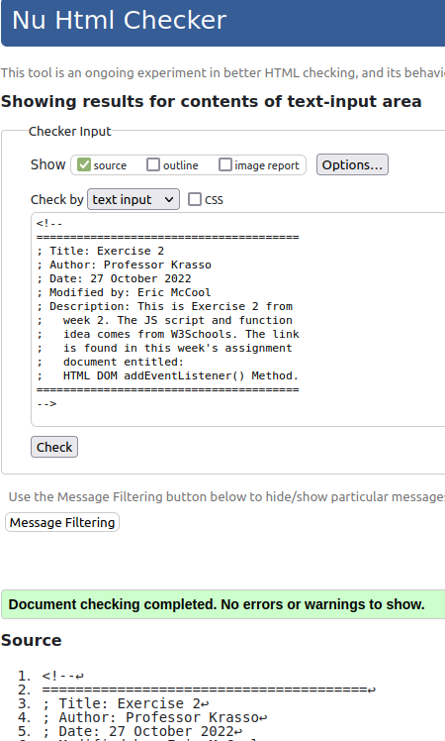

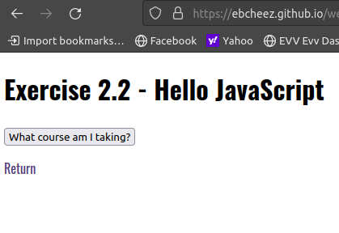

3
